

|  |  |  |  |  |  |  |  |  |
| --- | --- | --- | --- | --- | --- | --- | --- | --- |
|  | | | | | | | | |
|  | | Assignment | | | | |  | |
|  |  | | | | | | |  |
|  | | | |  |  | | | |
|  | | | | Yash Jain Roll No.: A28  Reg. No.: 11612088  Section : KE013 |  | | | |
|  | | | | Date03/04/2020Course CodeINT301Miss. Milanjit Kaur |  | | | |
|  | | |  | | |  | | |



|  |  |  |  |  |  |  |  |  |
| --- | --- | --- | --- | --- | --- | --- | --- | --- |
|  |  | | |  |  | | |  |
|  | INSTRUCTIONS | | | | | | |  |
|  |  | | |  |  | | |  |
|  |  | |  | | |  | |  |
|  |  |  | Consider a php form with columns Id, First-name, Last-name, Email-id.  Insert following data in the database and fetch all the data in descending order of First name. | | |  |  |  |
|  | | | | |
|  |  |  |  |
|  |  |



|  |  |  |  |  |  |  |  |  |
| --- | --- | --- | --- | --- | --- | --- | --- | --- |
|  | |  |  | | |  |  | |
|  | | THE PROCESS | | | | |  | |
|  | |  |  | | |  |  | |
|  | Description For this assignment, I have to write a registration webpage using HTML, CSS, PHP and MySQL.  The database must fully implement the registration process, maintaining the submitted information. The server and page behavior must meet the requirements listed above. A separate table to see the students currently enrolled. | | | | | | |  |
|  | MySQL Information | | |  |  | | |  |
|  | Database Name: CA2  Table Name: details  Table attributes:   1. ID 2. First_Name 3. Last_Name 4. Email   Database user: root  Database pass: 123 | | |  |  | | |  |

|  |  |  |  |  |  |  |
| --- | --- | --- | --- | --- | --- | --- |
|  | Test Cases | | | | |  |
|  | |  |  |  |  | |
|  | 1. **MySQL Databse Connectivity** 2. **Description: -** To check MySQL Database is connected to our PHP project. 3. **Input: -** Give a username and password of database. 4. **Processing: -** Server checks for the password and username are correct or not 5. **Output: -** Displays a database is connected or not.      1. **Database Exist** 2. **Description: -** To check database is created or not 3. **Input: -** Input a query to create and check a database 4. **Processing: -** Server checks for the database is exist or not 5. **Output: -** If the database is not created then it will create new database. | | | | |  |

1. **Table Exist**
2. **Description: -** To check table is exist in database or not
3. **Input: -** Input a query to create table
4. **Processing: -** Server checks for the table is exist or not
5. **Output: -** If the table is not created then it will create new table.

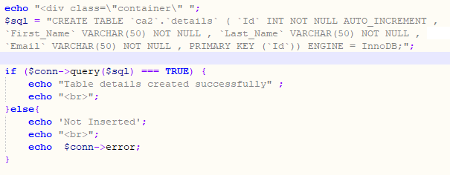

1. **Data Insertion**
2. **Description: -** To check data is inserted or not.
3. **Input: -** Input a insert query to insert data in table.
4. **Processing: -** Server upload a data into table
5. **Output: -** Display a message data is inserted or not.

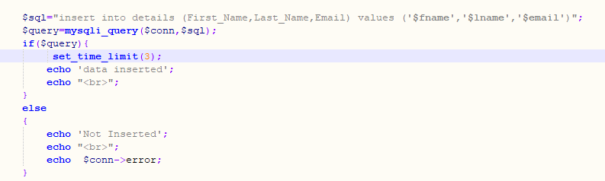

1. **Fetch Data**

a) **Description: -** Fetch all the data from table

b) **Input: -** Input a select query to fetch data from table.

c) **Processing: -** Server check a data is exist in table

d) **Output: -** Display a table of all data of table in descending order.

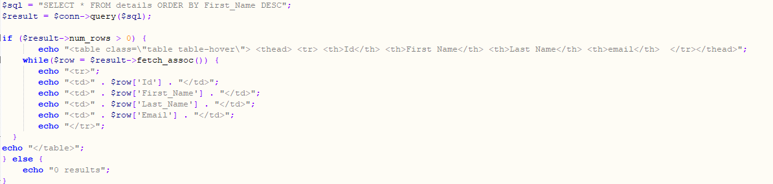

**Output Screenshot:**

